Jefferson Village Square | 2725 Jefferson St.  Carlsbad, CA 92008

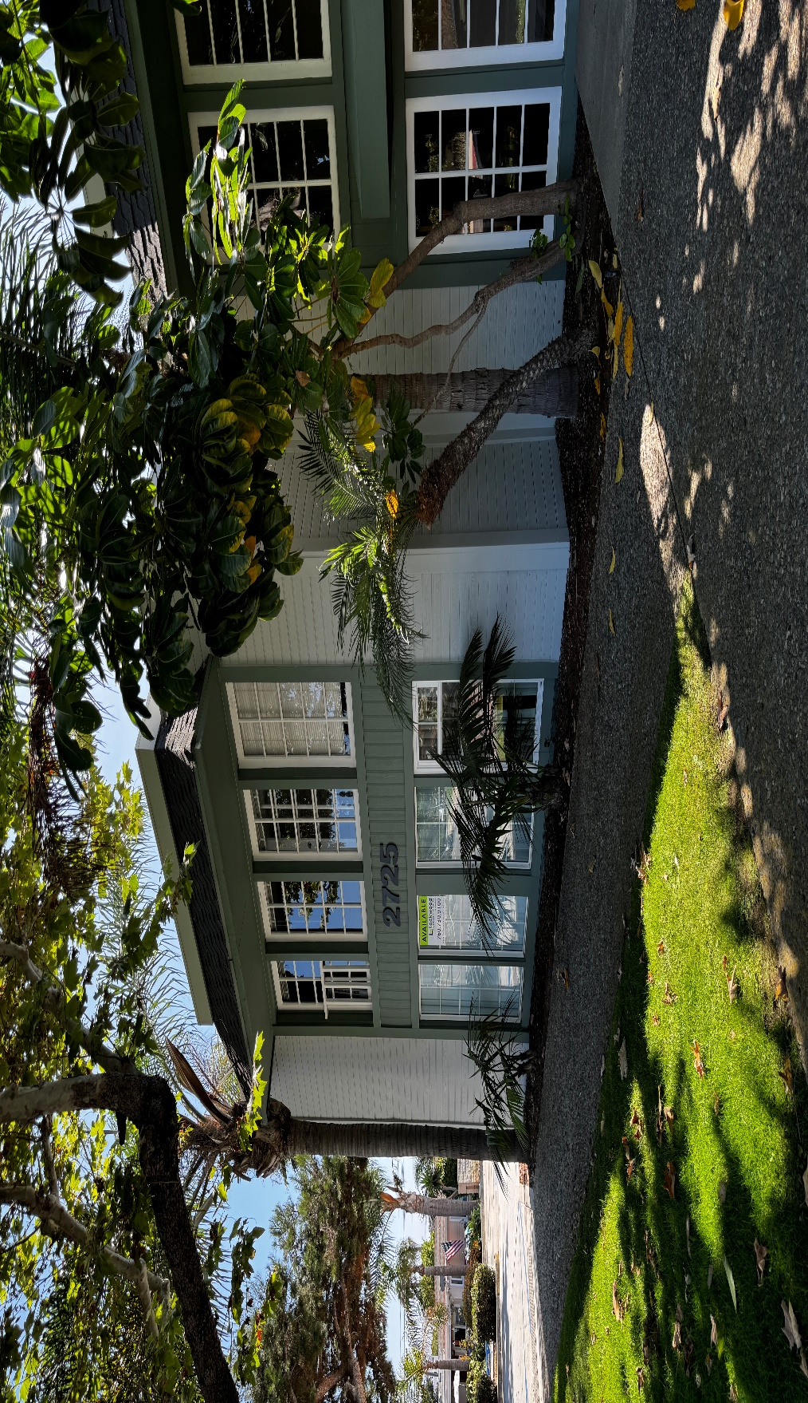

Convenient Carlsbad Village Location
Office suites from 161 to 861 square feet
Six Common Area Restrooms
Operable windows in all suites
On-site management, friendly atmosphere, and outside eating and smoking areas
17,527 SF, two-story office building with ample parking
Located at the corner of Laguna and Jefferson with great freeway access
ATT U-verse, ATT Fiber and Spectrum Internet available
Rents from $2.77 – $3.92 per sq. ft.

 | Lockwood  Commercial Realty | Charles Currey, SIOR  760.730.9100 x 301  chuck@lockwoodcommercial.com  #00658596

2725 Jefferson Street, Suite 1 Carlsbad CA, 92008 Phone 760.730.9100 Fax 760.730.9200 www.lockwoodcommercial.com
Information herein is deemed reliable and we have no reason to doubt its accuracy, but it is not guaranteed

Jefferson Village Square | 2725 Jefferson St.  Carlsbad, CA 92008

Suite # | Rentable Area | Cost Per Square Foot | Amenities
4A | 654 | $2.77 | First floor suite with two large window offices and large reception area. Rate does not include electricity.
6-104 | 210 | $3.92 | Executive Suites area, single room office with possible sink. Rate includes water, trash, electric and wireless internet.
6-107 | 161 | $3.88 | Executive suites area. Single room office with no water for sink.

All rates are subject to change without notice. No medical or healthcare services are allowed in second floor suites.
 | Lockwood  Commercial Realty | Charles Currey, SIOR  760.730.9100 x 301  chuck@lockwoodcommercial.com  #00658596
2725 Jefferson Street, Suite 1 Carlsbad CA, 92008 Phone 760.730.9100 Fax 760.730.9200 www.lockwoodcommercial.com
Information herein is deemed reliable and we have no reason to doubt its accuracy, but it is not guaranteed

