|  |  |
| --- | --- |
| For Sale  Carlsbad Industrial Building | 6066 Corte Del Cedro  Carlsbad, CA 92011 |

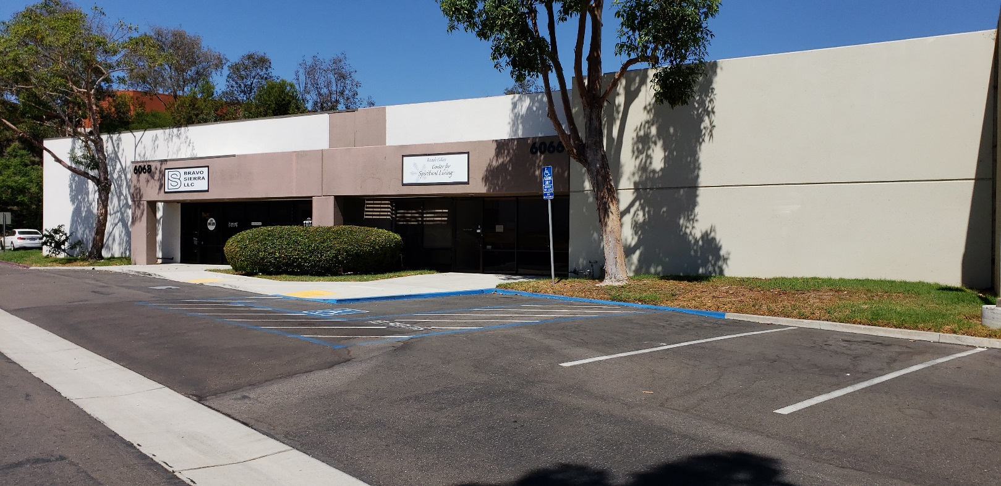

|  |  |
| --- | --- |
|  | 4,840 square feet of building area- easily divisible |
|  | 5,205 square foot lot- Landing Business Park |
|  | Approx. 2,700 square foot of office area and two restrooms |
|  | Improved warehouse area with finished full height ceiling |
|  | (2) 10 x 10 grade level truck doors - One filled in - restorable |
|  | Ample parking and building signage |
|  | Former place of religious worship with Use Permit |
|  | PM zone allows a variety of industrial uses |
|  | Excellent access to shopping, restaurants, Palomar Airport, the I-5 Freeway and the Pacific Ocean |

**Asking Price $939,280**

|  |  |  |  |
| --- | --- | --- | --- |
|  | **Lockwood**  Commercial Realty | Charles Currey, SIOR  760.730.9100 x 301  [chuck@lockwoodcommercial.com](mailto:chuck@lockwoodcommercial.com)  #00658596 |  |

|  |
| --- |
| 2725 Jefferson Street, Suite 1 Carlsbad CA, 92008 Phone 760.730.9100 Fax 760.730.9200 [www.lockwoodcommercial.com](http://www.lockwoodcommercial.com)  Information herein is deemed reliable and we have no reason to doubt its accuracy, but it is not guaranteed. |

|  |  |
| --- | --- |
| For Sale  Carlsbad Industrial Building | 6066 Corte Del Cedro Carlsbad, CA 92011 |

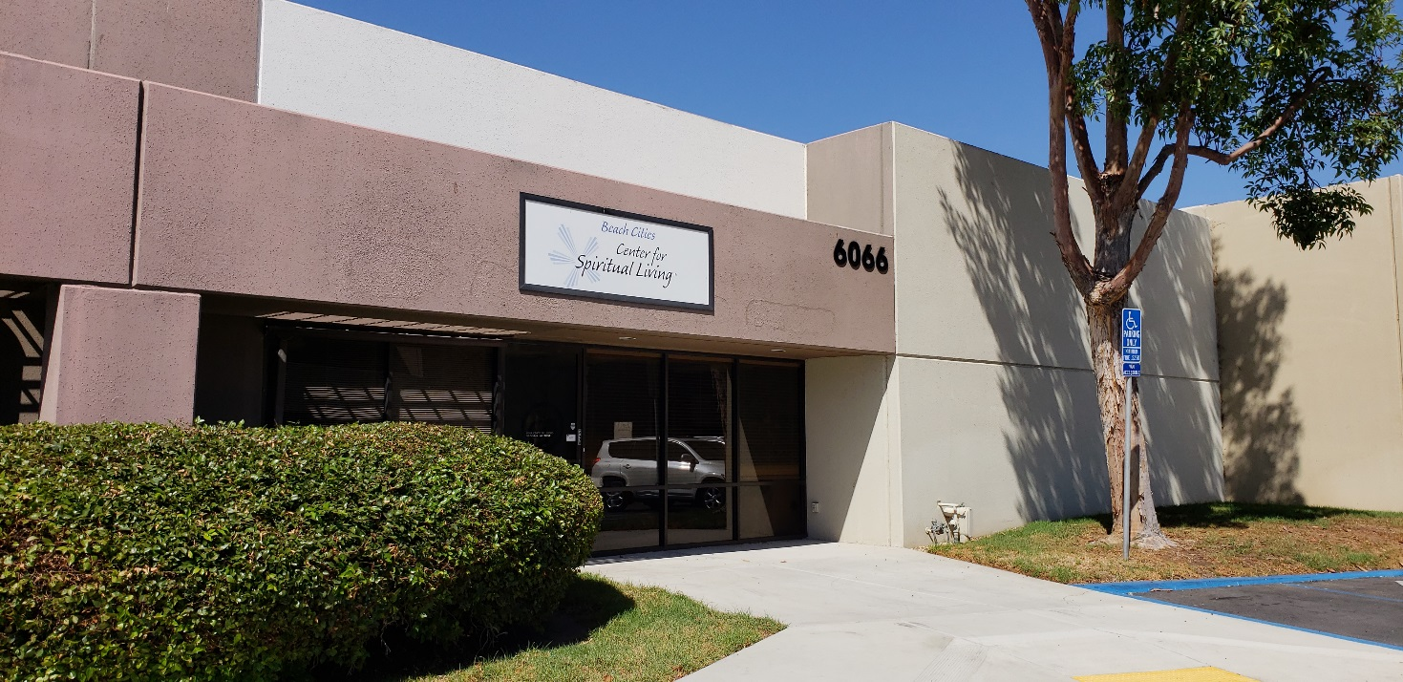

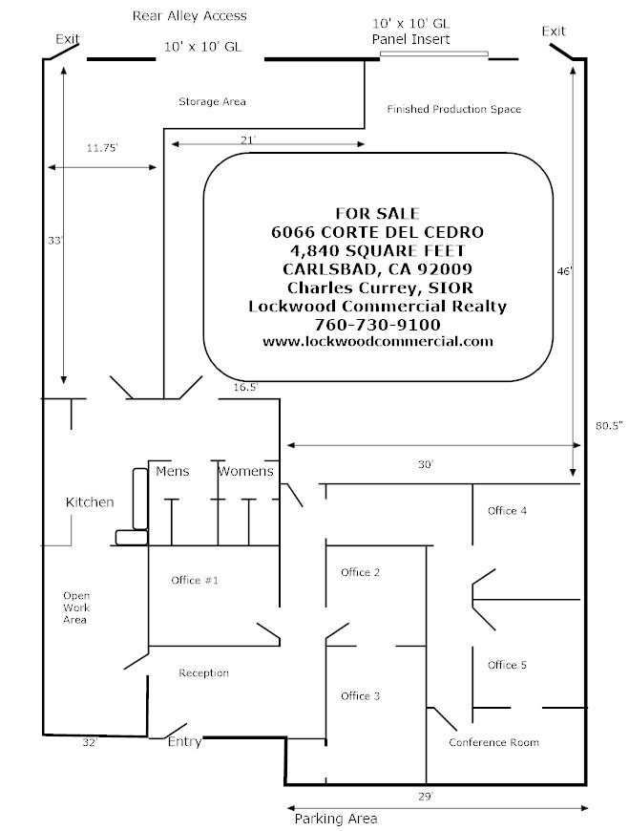

|  |  |  |  |
| --- | --- | --- | --- |
|  | **Lockwood**  Commercial Realty | Charles Currey, SIOR  760.730.9100 x 301  [chuck@lockwoodcommercial.com](mailto:chuck@lockwoodcommercial.com)  #00658596 |  |

|  |
| --- |
| 2725 Jefferson Street, Suite 1 Carlsbad CA, 92008 Phone 760.730.9100 Fax 760.730.9200 [www.lockwoodcommercial.com](http://www.lockwoodcommercial.com)  Information herein is deemed reliable and we have no reason to doubt its accuracy, but it is not guaranteed. |